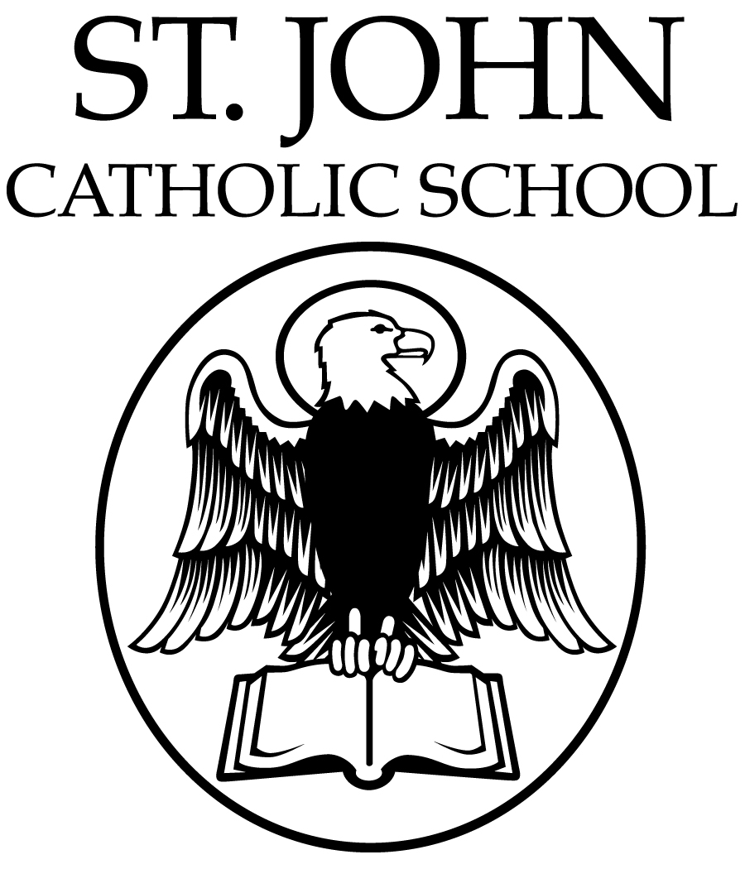

Dear Parents,

May is national Bike Month and Bike to School Month! This is a month-long event designed to encourage people of all ages across the country to engage in active transportation through cycling. In addition to being an enjoyable activity, bicycling can lead to lifelong healthy habits. This year’s theme is: Unlock your city.

We envision Bike to School Month as a family event that is inclusive and we hope to also introduce parents to the joy of bicycling. Because of this, we encourage families to ride together whenever possible. Whether you bike with your child to school, the park or to the grocery store, you are:
- creating daily exercise habits that help keep your child active and healthy;
- modeling safe and responsible riding while fostering your child’s independence; and
- reducing car traffic and carbon emissions.

Cascade Bicycle Club invites you and your student to join our friendly Bike to School Challenge, where students can receive fun and safety-oriented prizes for recording their minutes of activity in May. In addition, all students to who bike to school on National Bike to School Day on Wednesday, May 8 may receive a cool prize from Cascade Bicycle Club (supply limited)!

Please return this registration form to the school office and download the calendar to record your child's minutes of activity. Please turn in your calendar by Friday, May 31, so the school can total their collective minutes in time to receive prizes!

Here’s what we have planned for Bike to School month at St. John School.

National Bike to School Day!
Wednesday, May 8 at 8 a.m.

Photo/Video Release
By submitting this registration form, I understand and agree to the following photo/video release statements. I authorize the use, reproduction, and/or publishing of photographs and/or video that may pertain to my child, taken at St. John School Bike to School events, including images and/or voice without compensation. I understand that this material may be used by St. John School and/or their partners (Cascade Bicycle Club) in various publications, websites or for other related endeavors. Under no circumstances will my child’s image be published with their individual name connected to the image(s) other than associating them with our school. To opt out of the photo/video release, please contact the Bike to School coordinators listed below.

For more information about Bike to School Month and bicycle safety resources visit Cascade's website at http://www.cascade.org/bike-school or contact our Bike to School Coordinators: Pablo Kelley: pkelley@stjohnsea.org

Child’s Name:____________________________________________ Grade:______________

Teacher’s Name: ___________________________ Parent’s email:______________________

By signing below I (Parent/Guardian)______________ give permission for my child to participate in Bike to School month and will provide the support necessary for him or her to bike safely to and from school whenever possible for our family.

Furthermore, I understand and agree that neither Cascade Bicycle Club, Cascade Bicycle Club Education Foundation, its officers or agents, nor the instructors(s), or other volunteers, may be held liable in any way for any occurrence or accident in connection with Bike to School month and I further agree to save and hold harmless St. John School , the Cascade Bicycle Club, its officers and agents, and the instructor(s) from any claim by me, my family, estate, heirs or assigns arising out of my child’s participation in Bike to School month.

*Please note that, in general, young children are not prepared to ride on the street alone. We strongly encourage elementary school children to ride to school with their parents or another adult who can help reinforce traffic safety principles and monitor their riding if they are not ready to ride on their own.
___________________________________________________________________________
Parent/Guardian Signature Date

Please return this form to school office by May 8, 2019.

